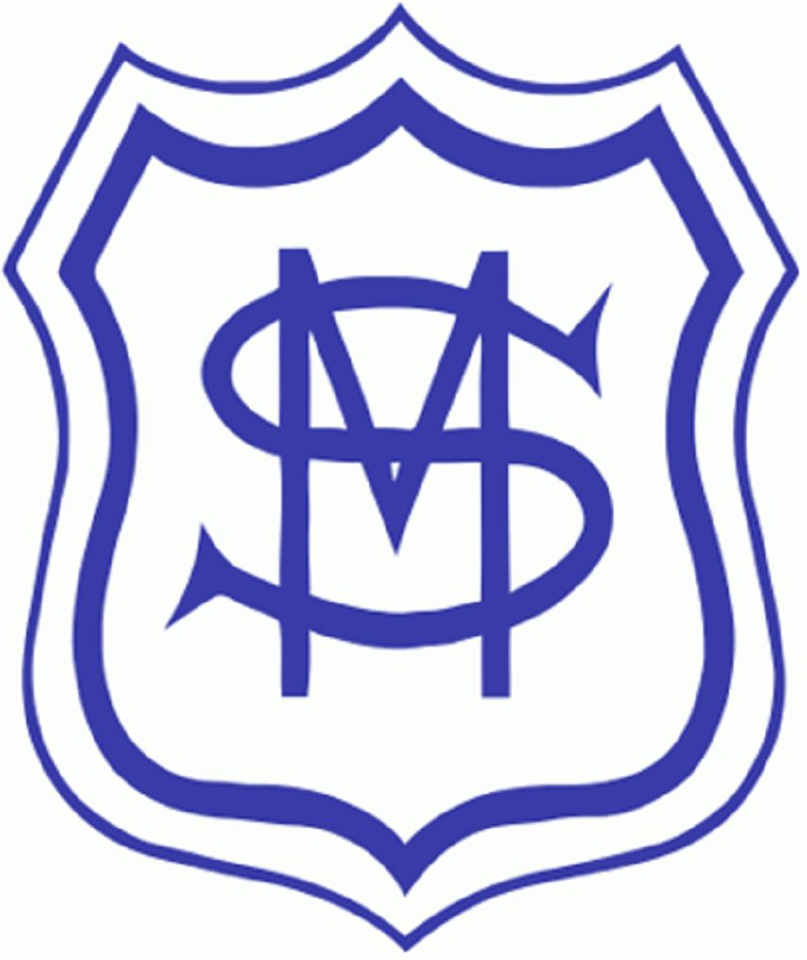

St Mary’s RC Primary School
Term Dates 2026-27

Please be aware that some dates differ from those published by Wandsworth.
These are our term dates for the academic year.

Autumn Term 2026
INSET Day: 2nd September
School Opens: 3rd September
Half Term: 26th – 30th October
INSET Day: 2nd November
School Opens: 3rd November
Last Day: 18th December
Spring Term 2027
School Opens: 4th January
Half Term: 15th – 19th February
Last Day of Spring Term: 25th March
Summer Term 2027
School Opens: 12th April
Half Term: 31st May – 4th June
INSET Day: 7th June
Last Day: 22nd July
Two INSET Days TBC

